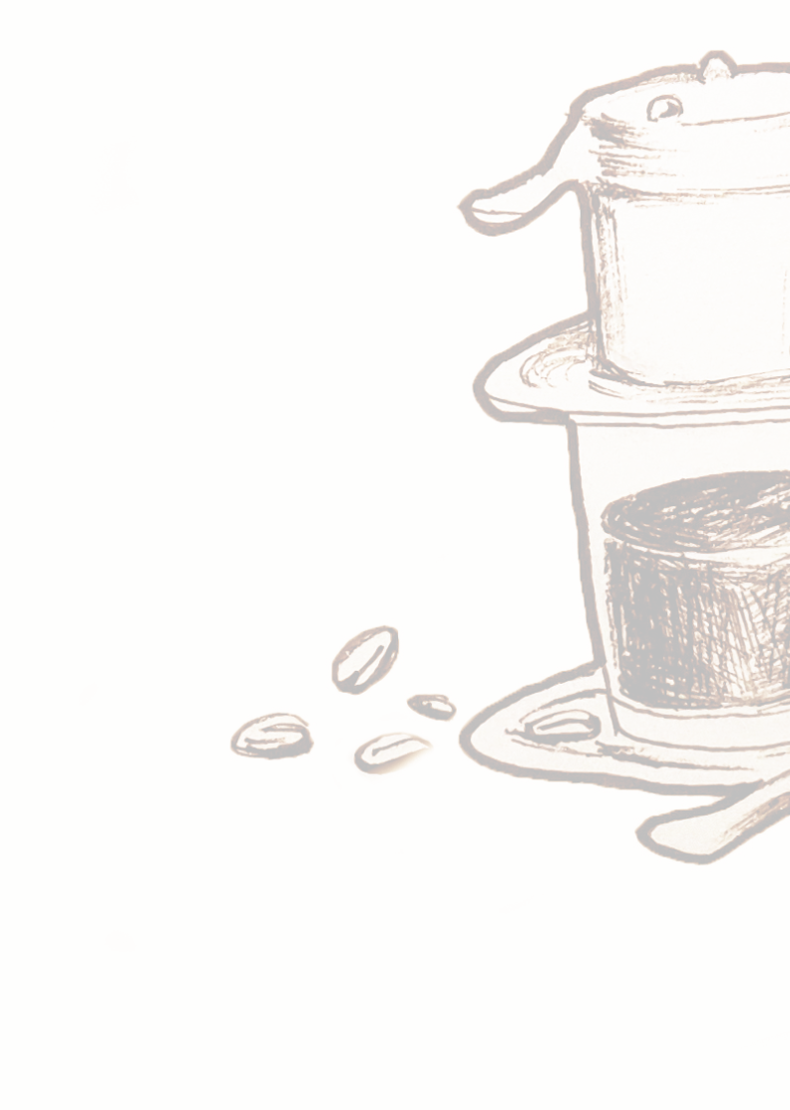

BIG DISHES
SMALL
Prawn Cake (2pcs)  Prawn and pork pate, mushroom, dill, shallot, lemongrass | 15
Summer Rolls (4pcs) | 9
Fresh rolls, prawn, pork, peanut, herbs, “nuoc cham”
Chicken Skewers | 11
Chicken thigh, kaffir lime, shallot, chili sauce
Lamb Skewers 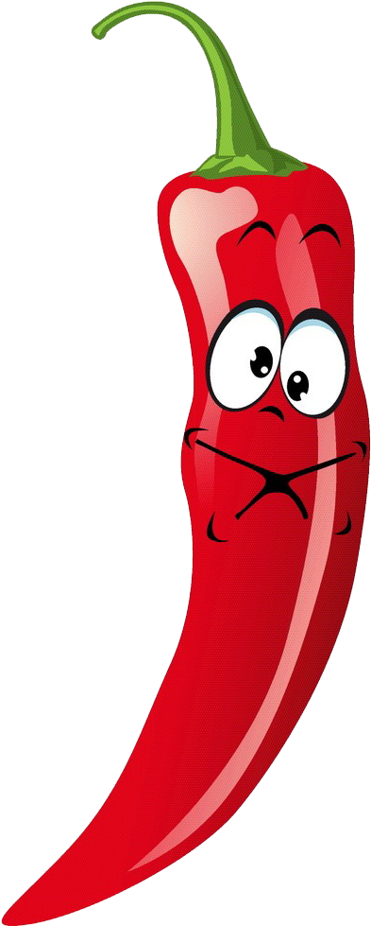 | 15
Galangal, lemongrass and turmeric, chilis
Popping Prawns (G) | 15
Dill, kaffir, curry leaves, chili powder, crumbed, peanut sauce
Softshell Crab Tamarind (G) | 18
Mixed green mango, Vietnamese mints, chili sauce
Prawn and Pork Siumai (5pcs) | 16
Prawn, Pork, mushroom, spring onion, dill, tomato sauce and haft roti
Grilled Calamari | 18
Squid, shallot, garlic sprout, chilis
Pork Rib Garlic | 16
Oven baked, dry chili, special sauce
Crispy Aubergine (V)(G)  Crumbed eggplants, shiso, garlic, honey sauce | 9
Wok Fried Broccoli Garlic(V)
Salted beans, dry chili, mushroom, garlic sauce  SIDE (ALL 2.50)  Steamed Rice  Rice Noodle  Kimchi  Vegie Pickle  Salted Peanut  Bread (4 pcs) | 12

Braised Beef in Wine (D)(G)
Carrot, cinnamon, star anise, tomatoes, lemongrass, red wine sauce and 3pcs breads

Half Duck Confit
Red curry sauce, kumara, mushroom, chili, garlic, coconut curry sauce

Tomyum Seafood
Prawns, squid, mussels, mushroom, lemongrass, kaffir lime

Flaming Coconut Prawn
Mushroom, lemongrass, chili, kaffir lime, mushroom

Caramelized Pork Belly
Pork belly, egg, ginger, pumpkin

Mussel pot
Garlic, chili, lemongrass, Vietnamese mint

Lemon Grass 1/2 Chicken
Lemongrass, Chili, oyster sauce, carrot potatoes

Prawn Fried Rice
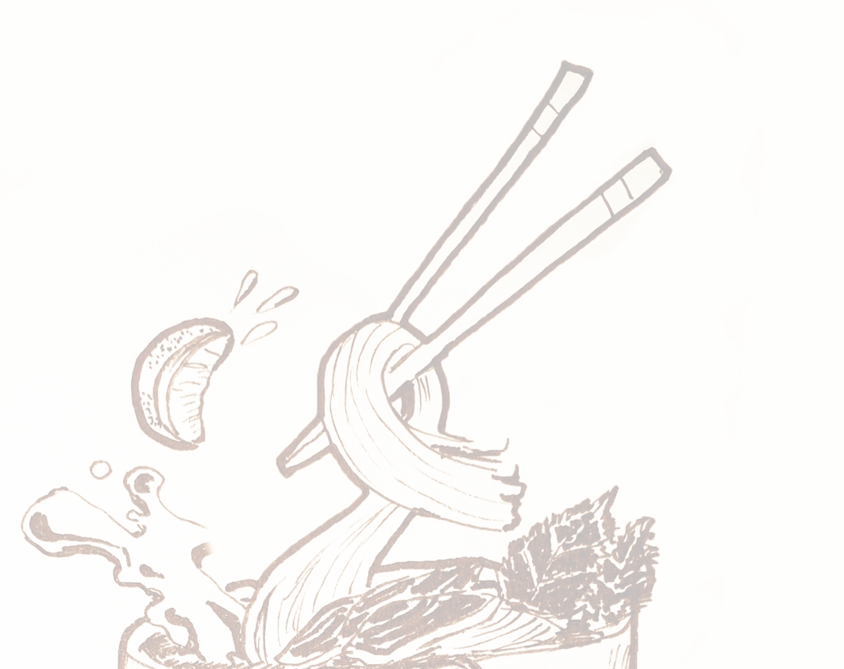
Prawns, Spring onion, fried shallot, pineapple
Mixed vegie

Kumara Curry (V)(G)
Kumara, carrot, pumpkins, onions in red curry

Tofu Curry (V)
Tofu with red curry served with Rice

DESSERT (ALL 6.99)

Mango Sago (D)
Tapioca, Mango, condensed milk and coconut cream

Black Sticky Rice Pudding (D)
Stewed Black sticky rice with dried apricots, raisins, Malibu caramel and coconut milk

24

31

31

29

24

19

24

16

22

17
NOODLES

Phở - Raw/ Stew beef Noodle 16

Raw beef or stew beef with rice noodle, soup and herbs

Pad Thai 18
Rice noodles, egg, tofu, chicken, bean sprout,
peanut, tamarind sauce, chili

Char Kway Teow 18
Stir fried rice noodles, egg, prawn, squid, chive,
peanut, sweet soy sauce

Stir Fried Glass Noodle / or Rice Noodle 18
Pork minced, mushroom, spring onion, fried shallot

Bun Cha/ Grilled Pork Noodles 22
Grilled Pork belly, meat balls, rice vermicelli, ‘nuoc cham’

SALAD

Pork Belly Papaya Salad (Vege option (V)) 16
–Vegetarian option available
Green papaya, peanut, Vietnamese mints, carrot house dressing

Beef Salad 18
Grilled beef, mixed green salad, cherry tomatoes, red onion,
Vietnamese mint, fried garlic, sesame, balsamic sauce

Chicken Salad 18
Green apple, bean sprout, Vietnamese herb, peanut,
Vietnamese herb, peanut, red onion, fruit sauce

Crispy Aubergine Salad (V)(G) 17
Red onion, onion, mint cucumber, beetroot, fried garlic and
lime juice.

NOTES
G) CONTAINS GLUTEN
(D) CONTAINS DAIRY
(V) VEGETARIAN

Please let your server know if you have any food
allergies and we will do our best to accommodate. We cannot guarantee the absence of nut traces in our food. Our menu is designed to share and may not arrive together.

